**IOT Experiment - 1**

Name: Pinnu Sai raj Saketh

Reg No.: 122010318048

**Experiment -1**

**Aim:** Control the LED with Arduino Board and tinkercad software.

**Hardware Requirements:**

● 1x Breadboard

● 1x Arduino Uno

● 1x LED

● 1x 330Ω Resistor

● 2x Jumper Wires

**Theory:**

**Arduino Uno:** The Arduino Uno is an [open-source](https://en.wikipedia.org/wiki/Open-source) [microcontroller board](https://en.wikipedia.org/wiki/Microcontroller_board) based on the [Microchip](https://en.wikipedia.org/wiki/Microchip_Technology) [ATmega328P](https://en.wikipedia.org/wiki/ATmega328P) microcontroller and developed by [Arduino.cc](https://en.wikipedia.org/wiki/Arduino).The board is equipped with sets of digital and analog [input/output](https://en.wikipedia.org/wiki/Input/output) (I/O) pins that may be interfaced to various [expansion boards](https://en.wikipedia.org/wiki/Expansion_board) (shields) and other circuits.

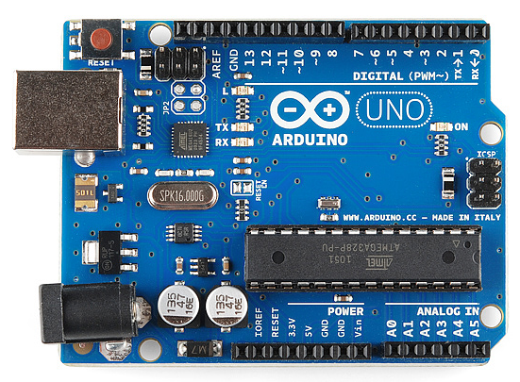

**Breadboard :** A breadboard, or protoboard, is a construction base for [prototyping](https://en.wikipedia.org/wiki/Prototype) of [electronics](https://en.wikipedia.org/wiki/Electronic_circuit). Originally the word referred to a literal bread board, a polished piece of wood used when slicing bread.

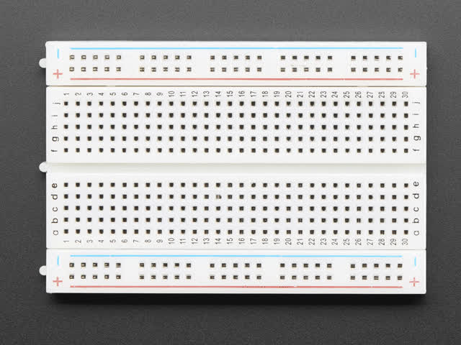

**LED :** A light-emitting diode (LED) is a [semiconductor](https://en.wikipedia.org/wiki/Semiconductor) [light source](https://en.wikipedia.org/wiki/Light_source) that emits light when [current](https://en.wikipedia.org/wiki/Electric_current) flows through it. [Electrons](https://en.wikipedia.org/wiki/Electron) in the semiconductor recombine with [electron holes](https://en.wikipedia.org/wiki/Electron_hole), releasing energy in the form of [photons](https://en.wikipedia.org/wiki/Photon).

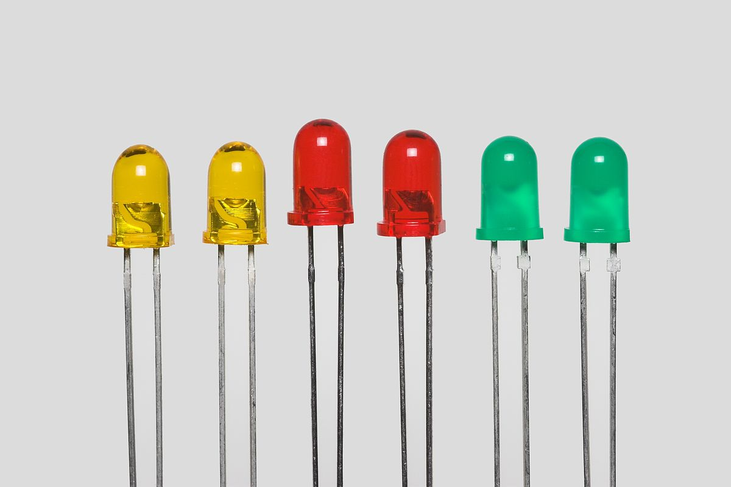

**Resistor :** A resistor is a passive two-terminal electrical component that implements electrical resistance as a circuit element. In electronic circuits, resistors are used to reduce current flow, adjust signal levels, to divide voltages, bias active elements, and terminate transmission lines, among other uses.

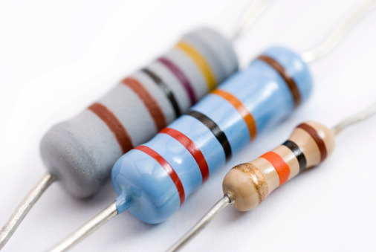

**Procedure:**

**1**.create a new account in [www.tinkercad.com](http://www.tinkercad.com/) or login with

existing gmail account.

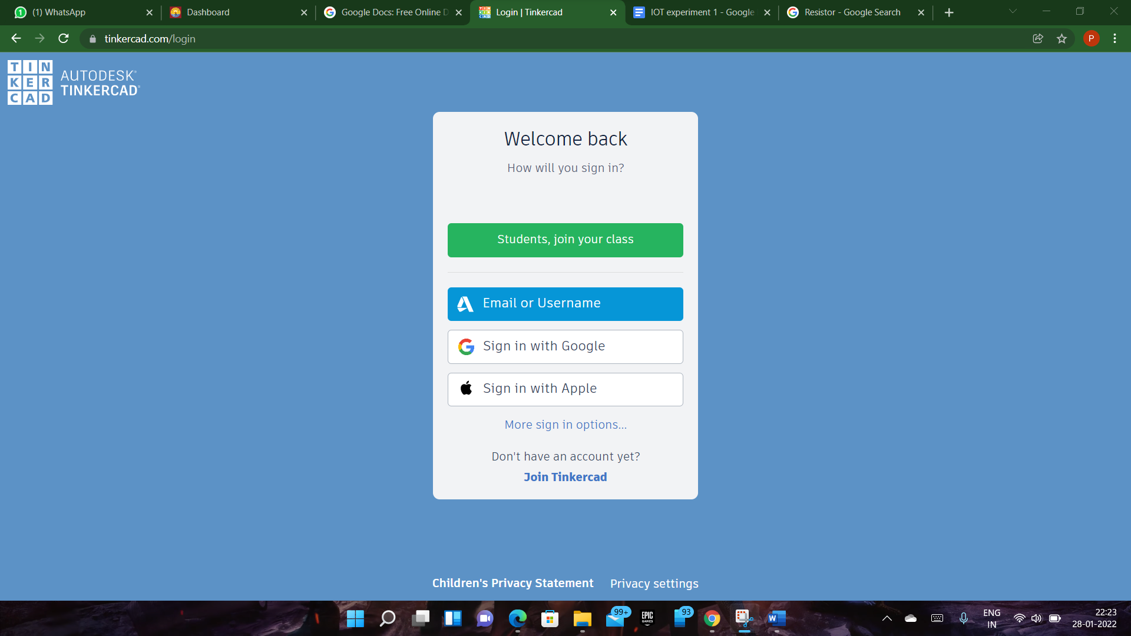

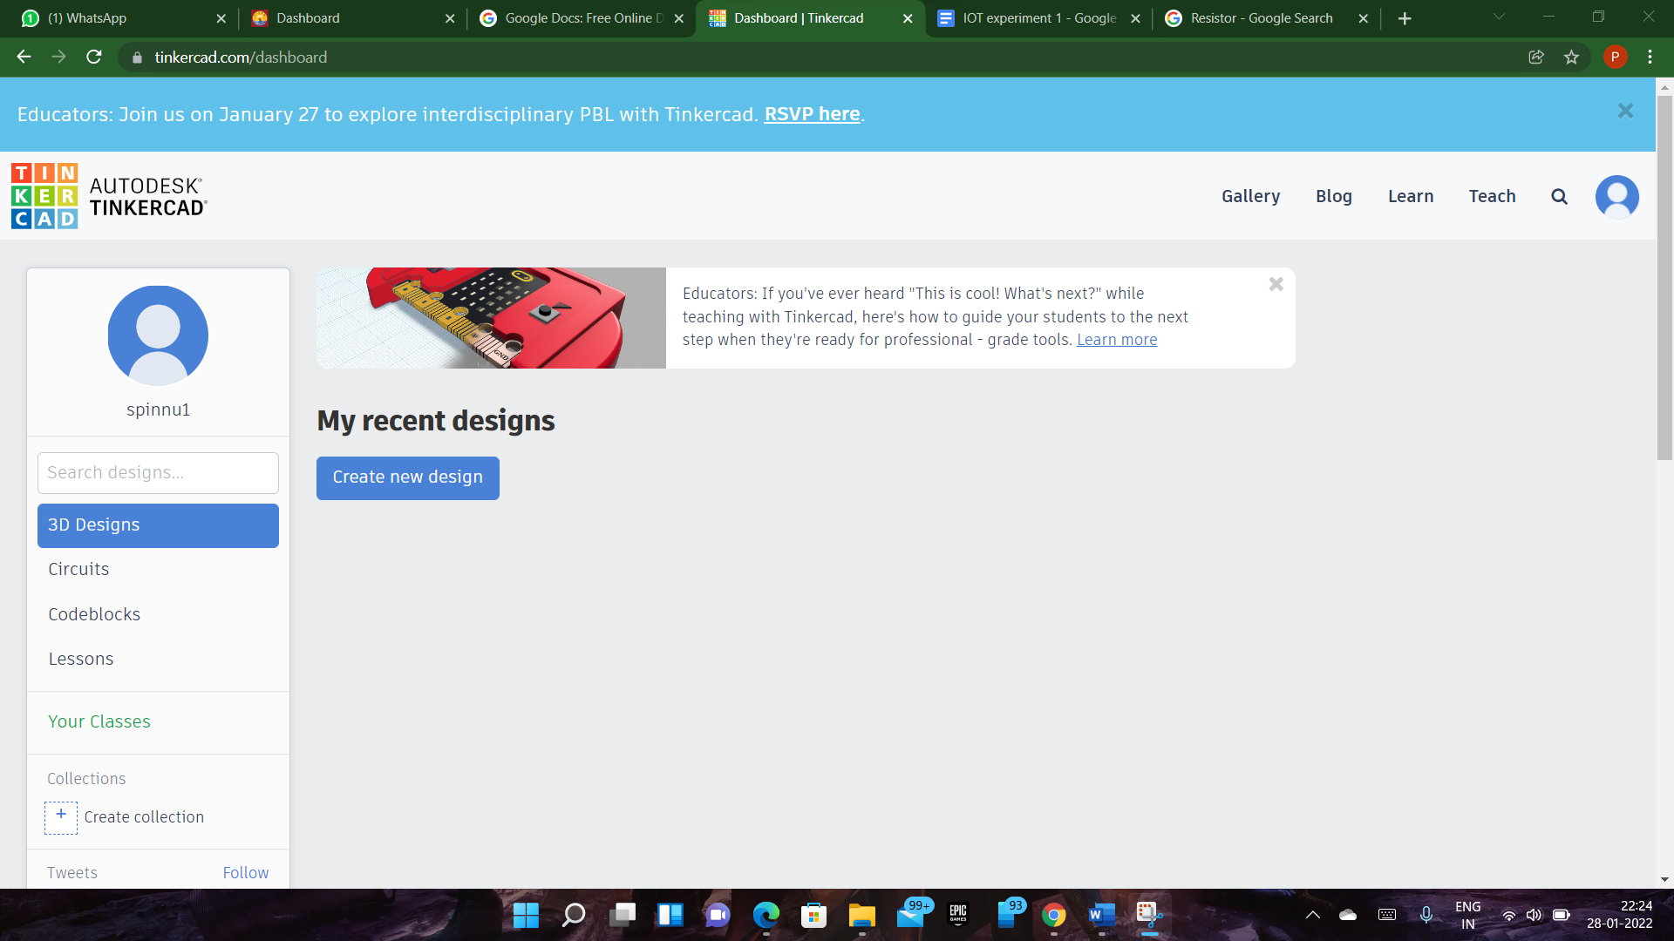

**2.** Click on go to create Collection and create a new collection.

**3.** Go to create menu and select circuit

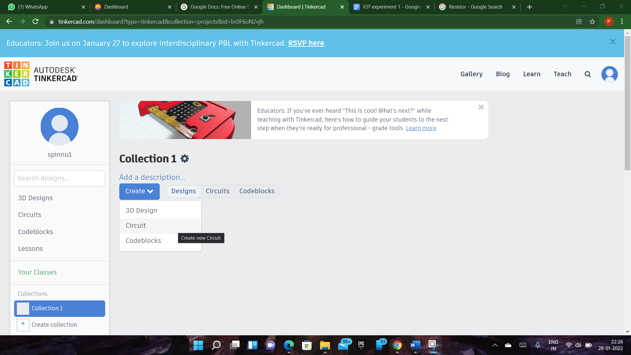

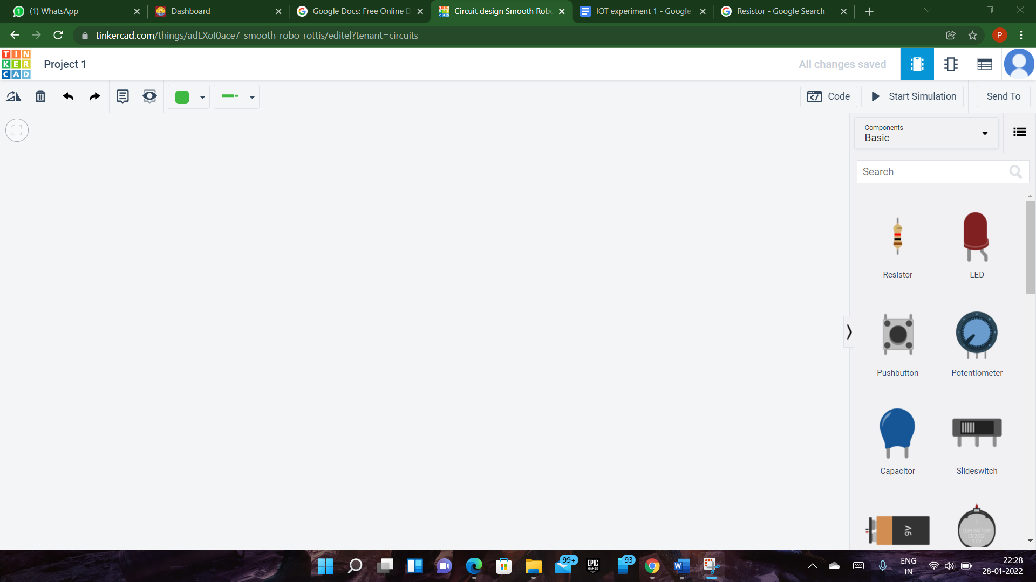

**4.** Select the Arduino and breadboard and place it in the design area.

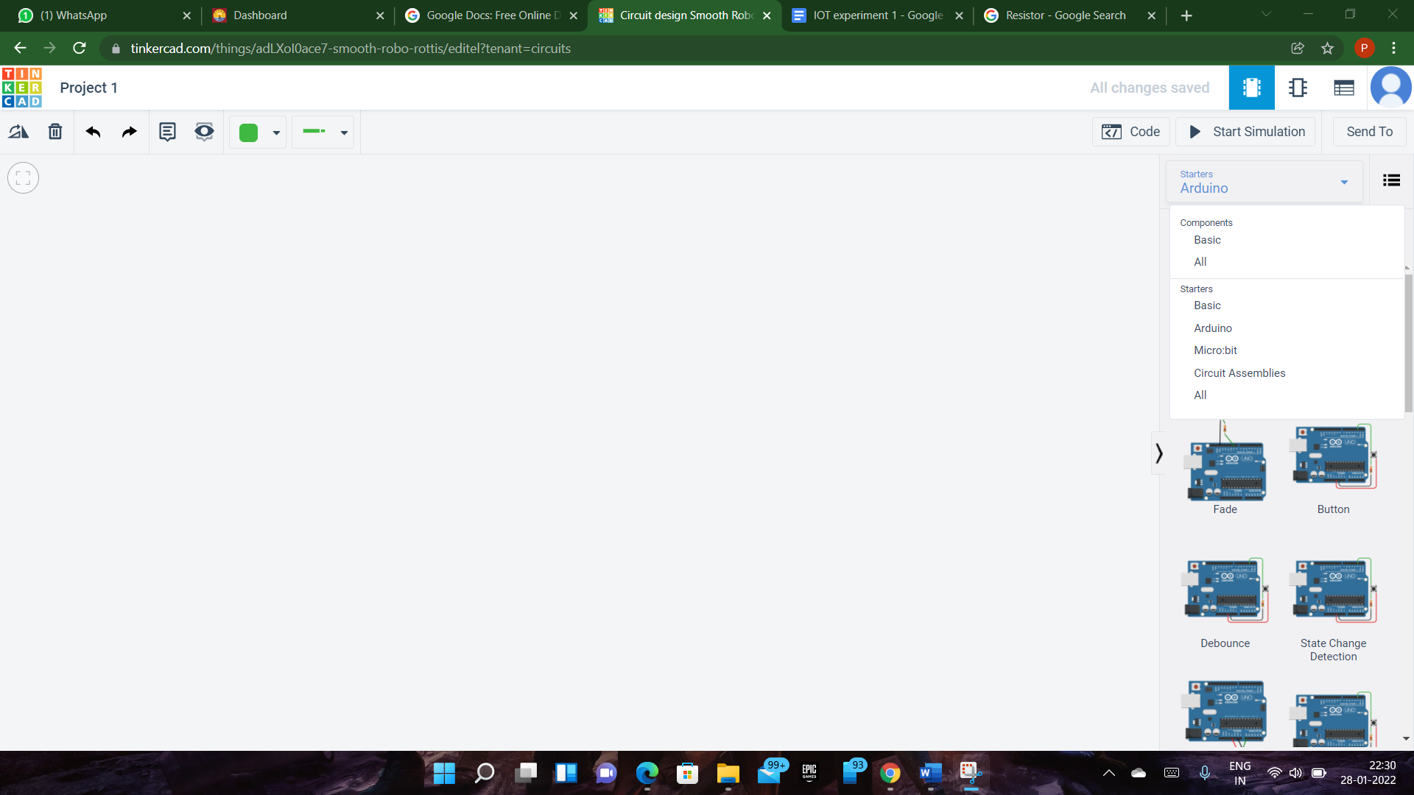

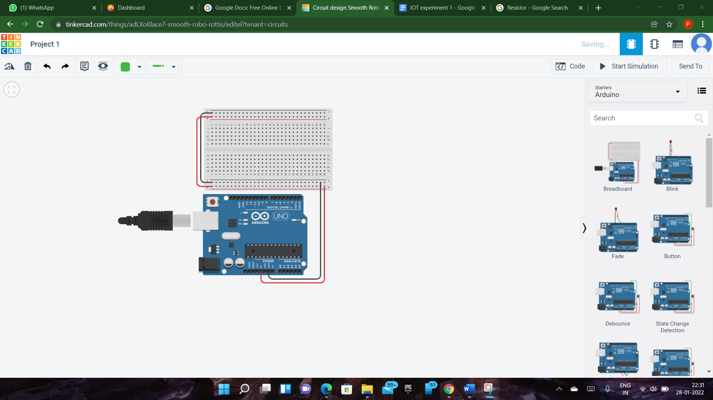

**5.** Search the component LED and resistor and make connections. Configure the resistor value as 330 ohms.

**6.** Attach the LED to an output pin of the Arduino D13.

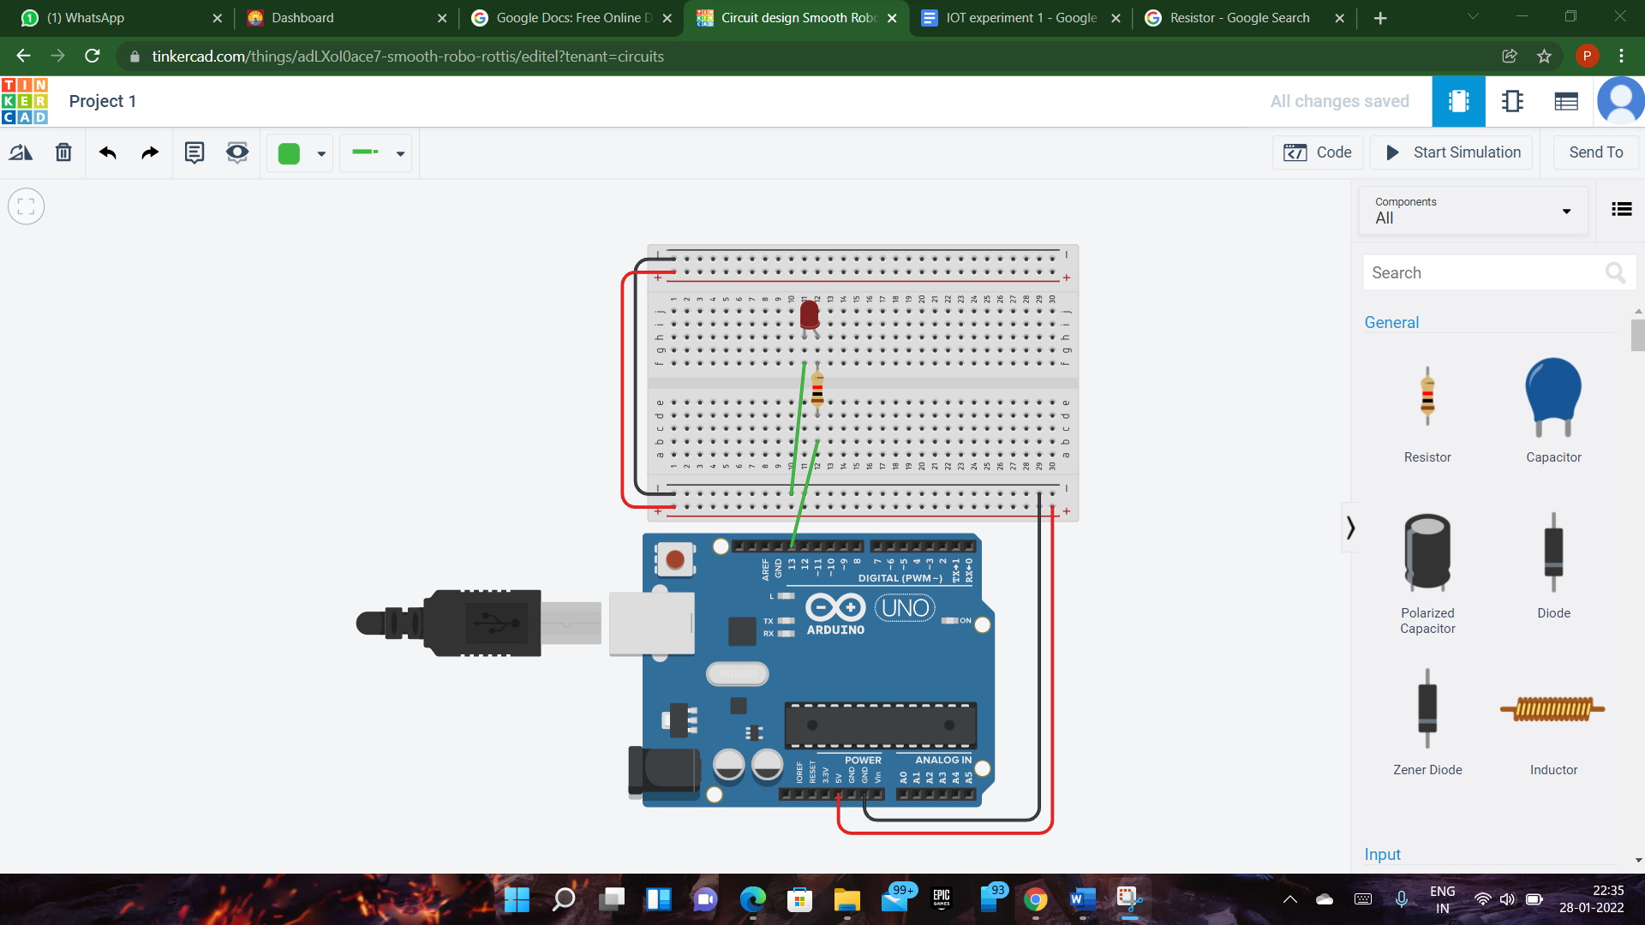

**7.** Once the circuit connection are ready, programming the Arduino can be done in three ways.

1. Using code blocks

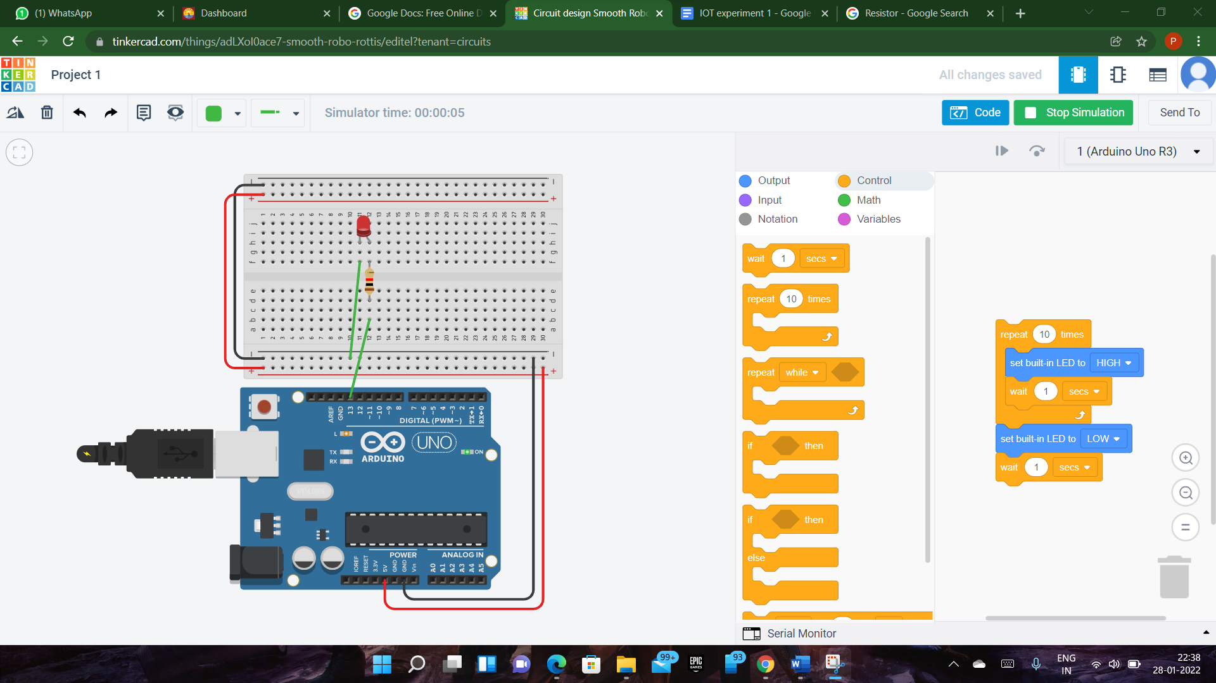

1. Using code blocks + text programming

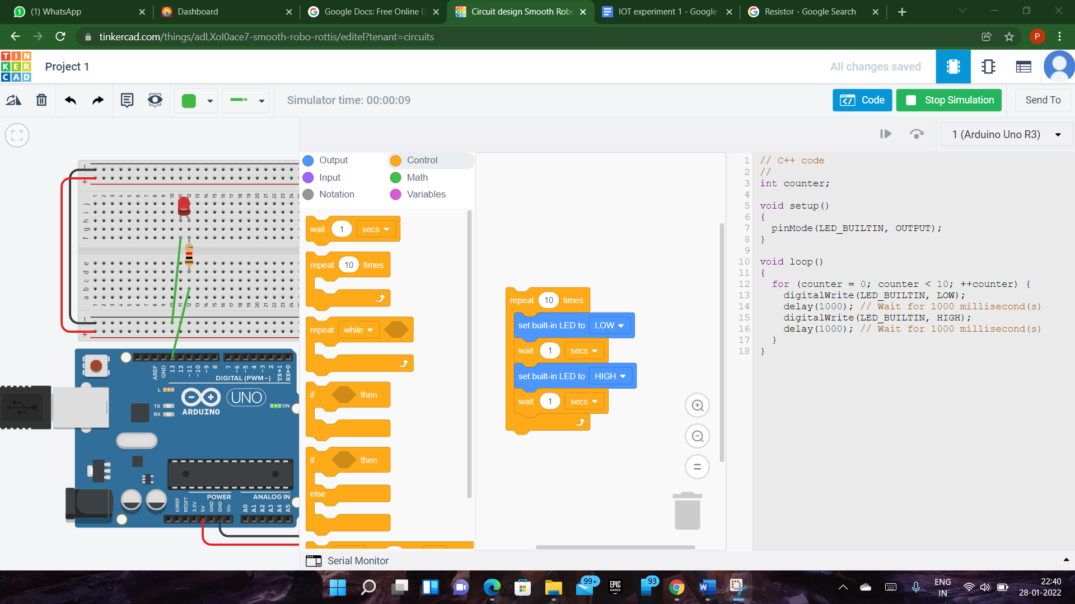

1. With text program

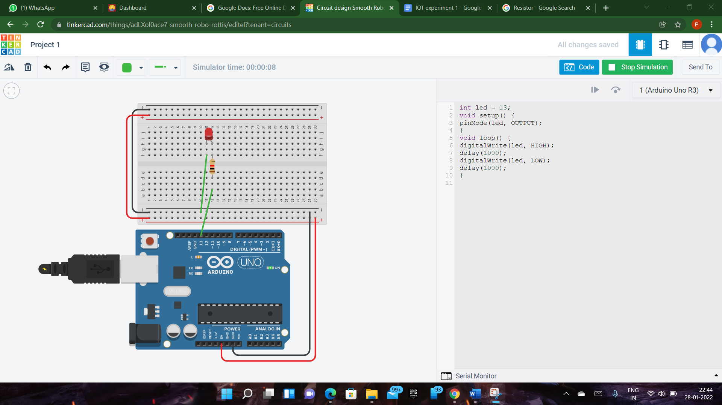

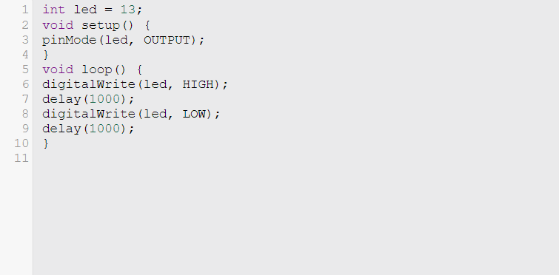

Lets try using a different pin of the Arduino – say D7. Move the red jumper lead from pin D13 to pin D7 and modify the following line near the top of the sketch:

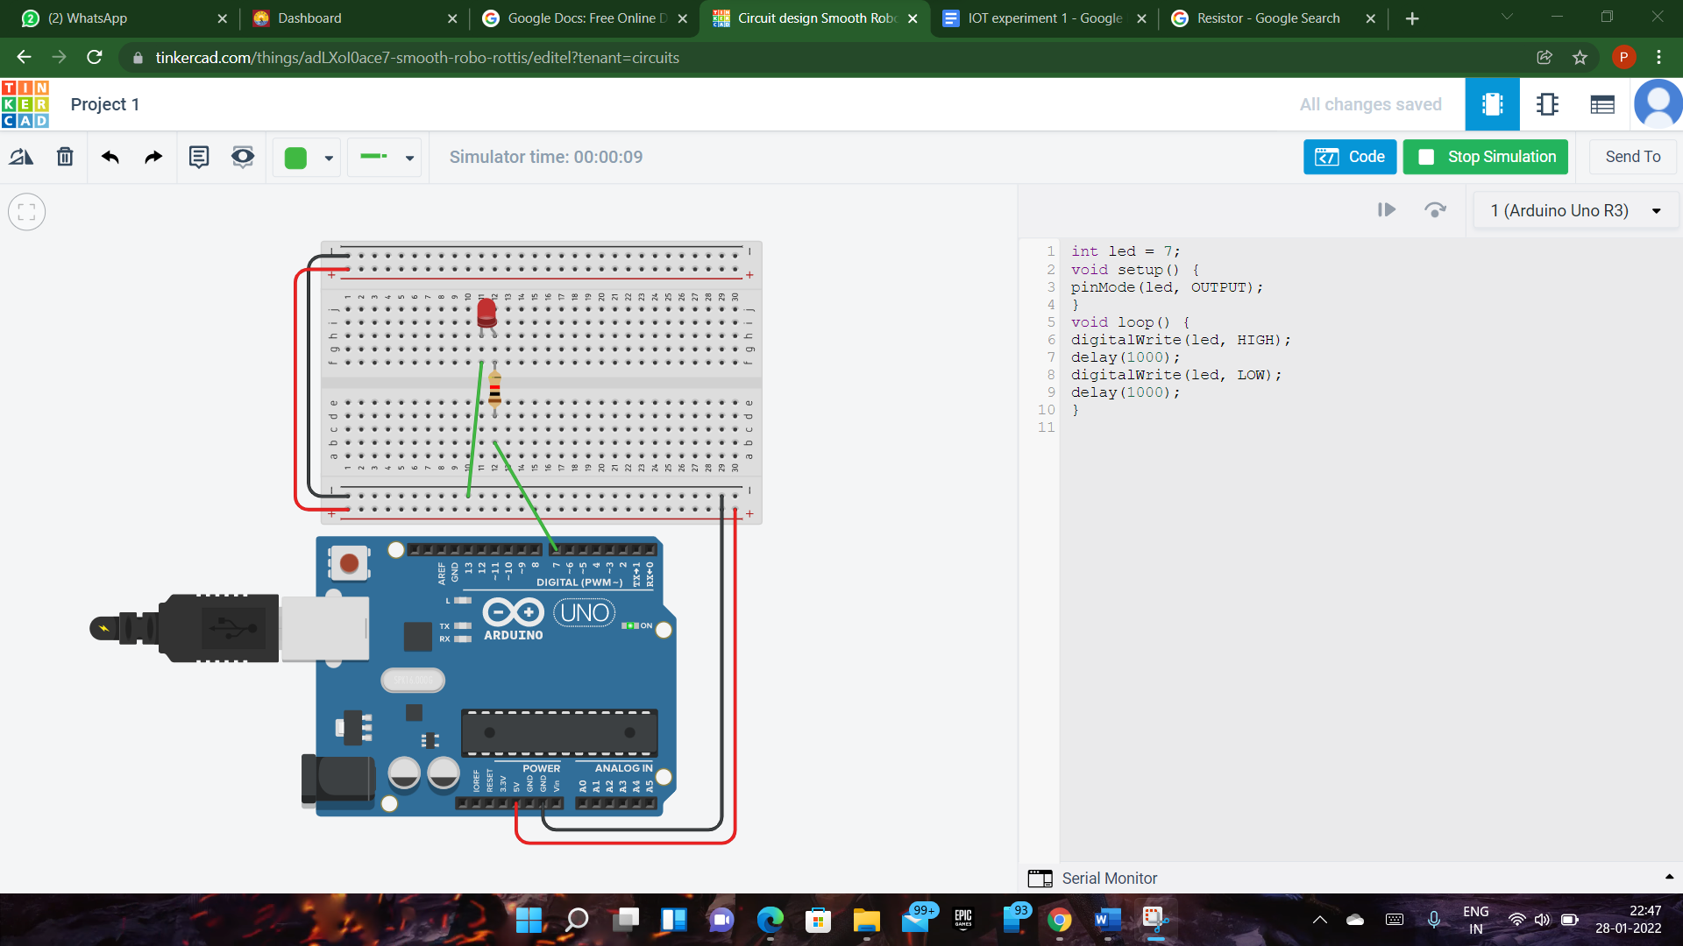

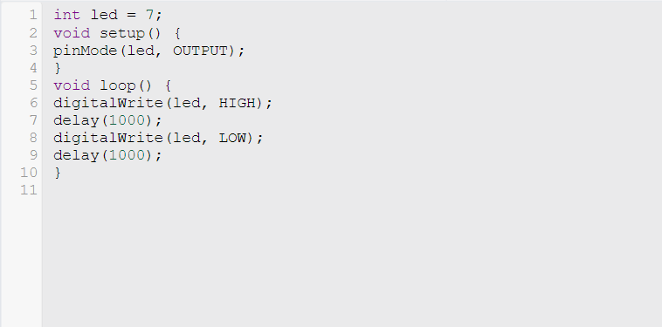

**Result:** Written program using Arduino IDE for Blinking LED.